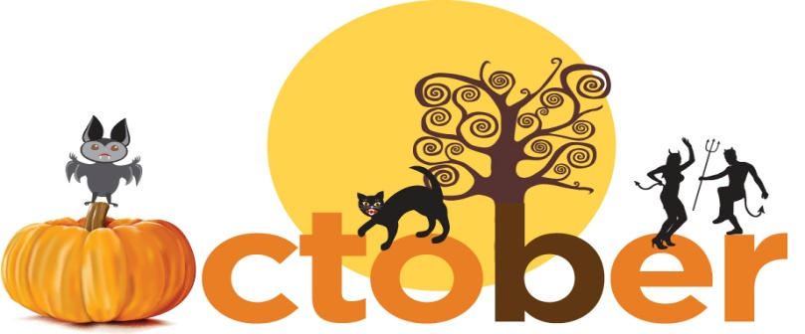

WEEKLY

Newsletter

FRANKLIN PHONETIC SCHOOL

Franklinphoneticschool.com

MC900022422[1]

October 19th, 2017

FRANKLIN FALCONS

"2011 Blue Ribbon School”

**Every Friday is early release**

Oct 20th Az state fair/Sunny slope Performance

Oct 21st Fall Festival

Oct 25th - 27th Parent Teacher Conference early

Release.

Nov 8th Picture Retake

Nov 21st Early Release

Nov 22nd -24th No School

Nov 25th Prescott Light Parade

Dec 2nd Prescott Christmas Parade

Dec 7th Band Concert 1pm & 7pm

Dec 14th Choir Concert 1pm & 7pm

Dec 21st Elementary Drama 1pm & 7pm

Dec 22nd Junior High Dance 9pm-12pm

Dec 25th -Jan 5th Christmas Break

Jan 15th No School

Feb 1st K-1ST Grade Musical

Feb 15th 2-3rd Grade Musical

Feb 13th Kindergarten Pictures

Feb 22nd Jazz Festival

Feb 28th Talent Show

Mar 12th -16t No School

Mar 24th PV Family Arts Festival

Mar 29th ABODA Band Festival

Mar 30th No School

April 23-24th 8th Grade Field Trip To Universal

Studios

Apr 26th 4th Grade Opera

May 1st Sunny Slope Performance

May 3rd Band Concert

May 4th-5th Northern Az Honor Band

May 10th Choir Concert

May 16th Elementary Awards 9am – 11am

May 16th Junior High Awards 1pm – 2:30pm

May 17th Junior High Drama

May 18th Kindergarten Graduation

May 21st 8th Grade Graduation Rehearsal 9-11pm

May 22nd 8th Grade Graduation 7pm

May 22nd Elementary Field Day

May 23rd Junior High Dance 6pm- 9pm

May 23 Junior High Field Day

FRIENDLY REMINDERS

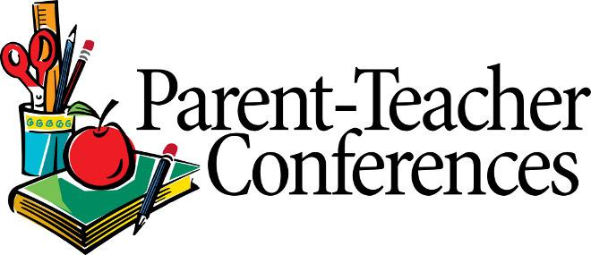

**Parent Teacher conferences are next week, October 25th, 26th and 27th. Please call to schedule.**

**October 25th, 26th and 27th are also early release days.**



**Parents please remember students are required to wear pants after fall break and students may begin wearing shorts again in March after Spring Break.**

**Remember that you can access your child’s grade through Family Link.**

**Phones are to be turned into the junior high office once the student arrives to school.**

**Lunch is available Monday – Friday for $2.85.**

**Nutrition information is available in the lunchroom. Please see attachment for this month’s breakfast and lunch menu.**

**Breakfast is free for all students who arrive to school on time.**  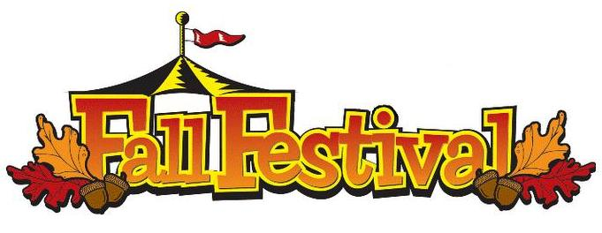

**The Fall Festival is Saturday October21st from 3pm-6pm. Please see attached flyer for details.**